**Alert Watch and Response Engine (AWARE)**

Installation Guide

for

Kernel Installation and Distribution System (KIDS)

and

Cache Server Page (CSP)



July 2015

Prepared by Harris Corporation

CLIN 0007AC

Revision History

| Creation Date | Version No. | Description/Comments | Author(s) | Reviewer(s) | Review Type | Issue Date |
| --- | --- | --- | --- | --- | --- | --- |
| 05/07/2014 | 0.01 | Initial | B. Tjahjo | G. Welch S. Wang S. Greenacre | Peer | 06/03/2014 |
| 06/10/2014 | 0.02 | Section 3.2 - added items 2e and 2f, updated item 9, and removed item 10; Added Section 3.4; Fixed document name reference in Section 1 and Section 4.2.3; Updated item 5 in Section 4.2.1 | B. Tjahjo |  |  | 06/12/2014 |
| 07/09/2014 | 0.03 | Added Section 3.5. | S. Greenacre |  |  | 07/21/2014 |
| 07/29/2014 | 0.04 | Added Section 3.6; Use a generic term describing the install file in Section 3.2 item 1, section 4.1, and section 4.2.2 item 4.  Added reference to test/production account in Section 4.1 and section 4.2.1 step 4.  CLIN 0007AC added to cover sheet indicating, per VA PMO concurrence, that deliverable satisfies contractual requirement for System Administration Manual. | B. Tjahjo |  |  | 09/04/2014 |
| 05/11/2015 | 0.05 | Added CPRS v1.0.30.15 as one of the required builds in Section 3.1  Updated section 3.2 to remove KIDS files no longer used.  Renamed Alert Cache Viewer to Alert Viewer. | B. Tjahjo S. Greenacre |  |  | 07/20/2015 |
|  |  |  |  |  |  |  |
|  |  |  |  |  |  |  |
|  |  |  |  |  |  |  |
|  |  |  |  |  |  |  |
|  |  |  |  |  |  |  |

Table of Contents

1 Introduction 1

2 Project Description 1

3 KIDS Installation 1

3.1 Installation Prerequisites 1

3.2 Installation Process 1

3.3 Sample KIDS Installation 3

3.4 Post Installation Instruction 6

3.5 Configure TaskMan 9

3.6 Add Alert Viewer URL on CPRS Tools Menu 10

4 CSP Installation 13

4.1 Preparation 13

4.2 Installation 13

4.2.1 Create CSP AWARE Web Application 13

4.2.2 Import Source Code XML 17

4.2.3 CSP Gateway User (CSPSystem) 20

5 Terms, Acronyms, Abbreviations, and Definitions 23

List of Tables

Table 1 – Terms, Acronyms, Abbreviations, and Definitions 23

List of Figures

Figure 1- Inhibit Logon Prompt 2

Figure 2 - System Management Portal 13

Figure 3 - Select Cache Server 14

Figure 4 - Web Application 14

Figure 5 - Create New Web Application 15

Figure 6 - Web Application Form 16

Figure 7 - Web Application Role 17

Figure 8 - Cache Studio 17

Figure 9 - Choose Change Namespace 18

Figure 10 - Select Cache Namespace 18

Figure 11 - Import Local 19

Figure 12 - Select AWARE CSP Source File 19

Figure 13- Import AWARE CSP Source File 20

Figure 14 - Launch View, Add, Edit User Definitions 20

Figure 15- List of User Definitions 21

Figure 16- Edit User CSP System Definition 21

Figure 17 - Assign Role to User CSPSystem 22

# Introduction

The purpose of this document is to provide instructions on how to install Alert Watch and Response Engine (AWARE) Kernel Installation and Distribution System (KIDS) build and AWARE Cache Server Pages (CSP) on Veterans Health Information Systems and Technology Architecture (VistA) instances at Department of Veterans Affairs (VA) facilities.

All sections of this guide can be performed by an Information Resource Management (IRM) programmer, and may require coordination with facility or regional server manager.

AWARE system utilizes both VistA instance and Microsoft Structured Query Language (MS SQL) server. This installation guide pertains to steps performed on VistA instance. The other installation guide pertains to steps performed on SQL Server as well as Internet Information Services (IIS) Server, SQL Server Reporting Services (SSRS), and CSP Gateway can be found in T4_AWARE_InstallGde-Server.

# Project Description

The Computerized Patient Record System (CPRS) View Alerts package delivers notification of non-life threatening critical test results; however, it does not track whether providers take appropriate follow-up actions in response to the alerts. Currently, the only way to track follow-up actions on critical alerts is through manual review of individual patient records. The innovation Alerts, Watch and Response Engine (AWARE) will track and monitor follow-up actions and will identify certain critical lab and imaging test result alerts that lack timely follow-up. AWARE also consists of a web-based knowledge base editor and a quality measures reporting tool.

# KIDS Installation

This patch is to be installed on VistA system and must be installed by the compliance date to conform to VHA Directive 2001-023.

Please schedule 10 minutes for KIDS install and about 30 minutes for Reminder Dialog installation.

## Installation Prerequisites

Fully patched packages required for CPRS v1.0.29.21 or CPRS v1.0.30.15 must be installed before installing this patch.

## Installation Process

1. Download and extract the latest KIDS_REMINDER_DIALOGS_V_1_x_VMS.zip file (for OpenVMS server) or KIDS_REMINDER_DIALOGS_V_1_x.zip (for Linux server) from AWARE download site ([https://54.225.241.69/svn/aware/Deployment/AWARE Version 1.1.x/](https://54.225.241.69/svn/aware/Deployment/AWARE%20Version%201.1.x/)) to a local location. The “x” in the filename represents the last increment.

The AWARE download site uses Subversion to store the software. Username is “**awareva**” and the password is “**P@sswd!**” is required to download the software.

1. There are multiple KIDS builds that need to be installed in this process. Repeat step 3 through 8 below for each KIDS build in this order:
   1. VEFA_1_0_x.KID (AWARE software)
   2. VEFA_ZEVH_1_x.KID (AWARE Test routines. **For Test Account only**)
   3. VEFA_1_0_xKB.KID (Data associated with the four AWARE Alert Types).
2. Access the Kernel Installation and Distribution System Menu [XPD MAIN]
3. Run the Installation option [XPD INSTALLATION MENU]
4. Load the KIDS file by performing the following steps:
   1. Run the Load a Distribution option [XPD LOAD DISTRIBUTION] to load the KIDS distribution.
   2. When prompted, enter the path and the KIDS file name of the KIDS file in step 2 above.
   3. When prompted to continue with the load, enter YES. A Distribution OK! Message will appear when the load is complete.
5. After loading the KIDS file, use the following options to verify the contents of the patch and to back up any affected routines.

* Verify Checksums in Transport Global [XPD PRINT CHECKSUM] – run this option to verify the integrity of the routine in the patch.
* Compare Transport Global to Current System [XPD COMPARE TO SYSTEM] – run this option to view all changes that will be made when the patch is installed. All components (routines, RPCs, and so on) in the patch will be compared.
* Backup a Transport Global [XPD BACKUP] – run this option to create a backup message of any routines exported with the patch. It will NOT backup any of the other changes.

1. After performing the load and any optional verification steps, perform the following steps to install the KIDS file:
   1. Run the Install Package(s) [XPD INSTALL BUILD] option.
   2. When prompted for the install name, enter <AWARE 1.0>.
   3. Answer NO to the following prompts

Want KIDS to INHIBIT LOGONs during the install? NO//

Want to DISABLE Scheduled Options, Menu Options, and Protocols? NO//

Figure - Inhibit Logon Prompt

1. When installation is finished, an Install Complete message will appear.
2. After the KIDS listed in step 2 are installed, Reminder Dialogs need to be installed for the four AWARE Alert Types via Reminder Exchange. (This is by a Clinical Application Coordinator in continued steps in the VistA Installation, Setup, Validation, and Initial Testing Guide, T4_AWARE_InstallGde-VistATest).

## Sample KIDS Installation

The sample installation below illustrates the installation of the VEFA_1_0_1.KID, which is located in a temporary path C:\AWARE\. Below are examples of screens that will appear during the installation.

Select OPTION NAME: **XPD INSTALLATION MENU** Installation

**1 Load a Distribution**

2 Verify Checksums in Transport Global

3 Print Transport Global

4 Compare Transport Global to Current System

5 Backup a Transport Global

6 Install Package(s)

Restart Install of Package(s)

Unload a Distribution

Select Installation Option: **1 Load a Distribution**

Enter a Host File: **C:\AWARE\VEFA_1_0_1.KID**

KIDS Distribution saved on Sep 01, 2011@16:30:06

Comment: VEFA ALRE 1.1

This Distribution contains Transport Globals for the following Package(s):

VEFA1 1.1

Distribution OK!

Want to Continue with Load? YES//

Loading Distribution...

VEFA1 1.1

Use INSTALL NAME: VEFA1 1.1 to install this Distribution.

1 Load a Distribution

**2 Verify Checksums in Transport Global**

3 Print Transport Global

4 Compare Transport Global to Current System

5 Backup a Transport Global

6 Install Package(s)

Restart Install of Package(s)

Unload a Distribution

Select Installation Option: **VERify Checksums in Transport Global**

Select INSTALL NAME: VEFA1 1.1 Loaded from Distribution 9/1/11@17:09:41

=> VEFA ALRE 1.1 ;Created on Sep 01, 2011@16:30:06

This Distribution was loaded on Sep 01, 2011@17:09:41 with header of

VEFA ALRE 1.1 ;Created on Sep 01, 2011@16:30:06

It consisted of the following Install(s):

VEFA1 1.1

Want each Routine Listed with Checksums: Yes// **YES**

DEVICE: HOME// TELNET PORT

PACKAGE: VEFA1 1.1 Sep 01, 2011 5:09 pm PAGE 1

-------------------------------------------------------------------------------

0 Routine checked, 0 failed.

1 Load a Distribution

2 Verify Checksums in Transport Global

3 Print Transport Global

4 Compare Transport Global to Current System

5 Backup a Transport Global

**6 Install Package(s)**

Restart Install of Package(s)

Unload a Distribution

Select Installation Option**: INStall Package(s)**

Select INSTALL NAME: VEFA1 1.1 Loaded from Distribution 9/1/11@17:09:41

=> VEFA ALRE 1.1 ;Created on Sep 01, 2011@16:30:06

This Distribution was loaded on Sep 01, 2011@17:09:41 with header of

VEFA ALRE 1.1 ;Created on Sep 01, 2011@16:30:06

It consisted of the following Install(s):

VEFA1 1.1

Checking Install for Package VEFA1 1.1

Install Questions for VEFA1 1.1

Incoming Files:

101.43 ORDERABLE ITEMS (including data)

Note: You already have the 'ORDERABLE ITEMS' File.

I will OVERWRITE your data with mine.

Want KIDS to INHIBIT LOGONs during the install? **NO//**

Want to DISABLE Scheduled Options, Menu Options, and Protocols? **NO//**

Enter the Device you want to print the Install messages.

You can queue the install by enter a 'Q' at the device prompt.

Enter a '^' to abort the install.

DEVICE: HOME//**<RET>** TELNET PORT

VEFA1 1.1

Oct 28, 2013@08:19:36

Installing Data Dictionaries:

Oct 28, 2013@08:19:36

Installing Data:

Oct 28, 2013@08:19:36

Updating Routine file...

Updating KIDS files...

VEFA1 1.1 Installed.

Oct 28, 2013@08:19:36

No link to PACKAGE file

NO Install Message sent

100% Sample KIDS Installation Process (Continued)

Complete

Install Completed

## Post Installation Instruction

Create a VEFA SQL PROXY,USER proxy account in the NEW PERSON file  (#200) using the Foundations Management [XOBU SITE SETUP MENU]. This Proxy User is used by the AWARE SQL Transporter to update the AWARE SQL database with the current AWARE VistA Data. This user requires context option VEFA AWARE GET ALERT CACHE to be added to its secondary menu. Site IRM will need to take note of the ACCESS and VERIFY codes and keep these codes in a place that can be later retrieved since these codes will need to be provided to the AWARE point of contact in order to configure the AWARE SQL Transporter. See the QI Manager Install Guide. Below is a screen shot example.

Select OPTION NAME**: FOUNDATIONS MANAGEMENT** XOBU SITE SETUP MENU Foundations

Management

Foundations Management

...HMMM, JUST A MOMENT PLEASE...

Foundations Manager :: Main Jun 10, 2014@15:53:51 Page: 0 of 0

<<< VistALink Parameters >>>

VistALink Version: 1.6 Heartbeat Rate: 600 Latency Delta: 5

<<< VistALink Listener Status Log >>>

ID Box-Volume Port Status Status Date/Time Configuration

Enter ?? for more actions

SP Site Parameters SL Start Listener

CFG Manage Configurations STP Stop Listener

CP Enter/Edit Connector Proxy User SB Start Box

RE Refresh CU Clean Up Log

CM Connection Manager

Select Action:Quit//**CP**

Enter NPF CONNECTOR PROXY name : **VEFA SQL PROXY,USER**

Are you adding 'VEFA SQL PROXY,USER' as a new NEW PERSON (the 1544TH)? No// **Y**

(Yes)

Checking SOUNDEX for matches.

No matches found.

Want to edit ACCESS CODE (Y/N): **Y**

Enter a new ACCESS CODE <Hidden>: **********

Please re-type the new code to show that I have it right: ********

OK, Access code has been changed!

The VERIFY CODE has been deleted as a security measure.

You will need to enter a new VERIFY code so the user can sign-on.

Want to edit VERIFY CODE (Y/N): **Y**

Enter a new VERIFY CODE: *********

Please re-type the new code to show that I have it right: *********

OK, Verify code has been changed!

After the VEFA SQL PROXY,USER has been defined, the XMUSER menu will need to be added as the PRIMARY MENU option and add the VEFA AWARE GET ALERT CACHE broker menu as a Secondary Menu option. Below is a screen shot example:

Select OPTION NAME: USER MANAGEMENT

1 USER MANAGEMENT XUSER User Management

2 USER MANAGEMENT MENU XUOPTUSER User Management Menu

CHOOSE 1-2: **1 XUSER**  User Management

Add a New User to the System

Grant Access by Profile

Edit an Existing User

Deactivate a User

Reactivate a User

List users

User Inquiry

Switch Identities

File Access Security ...

Clear Electronic signature code

Electronic Signature Block Edit

List Inactive Person Class Users

Manage User File ...

OAA Trainee Registration Menu ...

Person Class Edit

Reprint Access agreement letter

You have PENDING ALERTS

Enter "VA to jump to VIEW ALERTS option

Select User Management Option: **EDit** an Existing User

Select NEW PERSON NAME: **VEFA SQL PROXY,USER**

Edit an Existing User

NAME: VEFA SQL PROXY,USER Page 1 of 5

_______________________________________________________________________________

NAME... VEFA SQL PROXY,USER INITIAL:

TITLE: NICK NAME:

SSN: DOB:

DEGREE: MAIL CODE:

DISUSER: TERMINATION DATE:

Termination Reason:

PRIMARY MENU OPTION: **XMUSER**

Select SECONDARY MENU OPTIONS: **VEFA AWARE GET ALERT CACHE**

Want to edit ACCESS CODE (Y/N): FILE MANAGER ACCESS CODE:

Want to edit VERIFY CODE (Y/N):

Select DIVISION:

SERVICE/SECTION: INFORMATION SYSTEMS CENTER

_______________________________________________________________________________

## Configure TaskMan

AWARE has a new process (**VEFA AWARE ALERT CACHE BUILDER**) that needs to be scheduled to run on a periodic basis. This task looks for new AWARE Alerts and adds them to the Alert Cache file (DATA DICTIONARY #19008.2 -- VEFA AWARE ALERT CACHE FILE). This will determine how often the VistA AWARE Alert Viewer is updated with new AWARE Alerts.

Select OPTION NAME:

**Taskman Management ... [XUTM MGR]**

<CPM> Select Taskman Management Option: ??

**Schedule/Unschedule Options [XUTM SCHEDULE]**

<CPM> Select Taskman Management Option: schedule/Unschedule Options

Select OPTION to schedule or reschedule: **VEFA AWARE ALERT CACHE BUILDER ...OK? Yes// (Yes)**

Edit Option Schedule

Option Name: VEFA AWARE ALERT CACHE BUILDER

Menu Text: AWARE ALERT CACHE BUILDER TASK ID:

__________________________________________________________________________

QUEUED TO RUN AT WHAT TIME: JUL 2,2014@17:03:45

DEVICE FOR QUEUED JOB OUTPUT:

QUEUED TO RUN ON VOLUME SET:

RESCHEDULING FREQUENCY: **60S 🡨 Task will run every 60 seconds**

TASK PARAMETERS:

SPECIAL QUEUEING:

_____________________________________________________________________________

Exit **Save**  Next Page Refresh

Enter a command or '^' followed by a caption to jump to a specific field.

COMMAND: **S** Press <PF1>H for help

## Add Alert Viewer URL on CPRS Tools Menu

Alert Viewer is designed to work with CPRS seamlessly. With an exception of the initial Alert Viewer login, it could be launched from CPRS without re-entering Access/Verify codes. The following steps show how to add Alert Viewer URL to VistA’s CPRS Tools menu.

Select OPTION NAME: **ORMGR CPRS Manager Menu**

CL Clinician Menu ...

NM Nurse Menu ...

WC Ward Clerk Menu ...

**PE CPRS Configuration (Clin Coord) ...**

IR CPRS Configuration (IRM) ...

Select CPRS Manager Menu <TEST ACCOUNT> Option:**PE**

AL Allocate OE/RR Security Keys

KK Check for Multiple Keys

DC Edit DC Reasons

**GP GUI Parameters ...**

GA GUI Access - Tabs, RPL

MI Miscellaneous Parameters

NO Notification Mgmt Menu ...

OC Order Checking Mgmt Menu ...

MM Order Menu Management ...

LI Patient List Mgmt Menu ...

FP Print Formats

PR Print/Report Parameters ...

RE Release/Cancel Delayed Orders

US Unsigned orders search

EX Set Unsigned Orders View on Exit

NA Search orders by Nature or Status

CM Care Management Menu ...

DO Event Delayed Orders Menu ...

LO Lapsed Orders search

PM Performance Monitor Report

Select CPRS Configuration (Clin Coord) <TEST ACCOUNT> Option: **GP**

CS GUI Cover Sheet Display Parameters ...

HS GUI Health Summary Types

**TM GUI Tool Menu Items**

MP GUI Parameters - Miscellaneous

UC GUI Clear Size & Position Settings for User

RE GUI Report Parameters ...

NV GUI Non-VA Med Statements/Reasons

EX GUI Expired Orders Search Hours

RM GUI Remove Button Enabled

NON GUI Remove Button Enabled for Non-OR Alerts

CLOZ GUI Edit Inpatient Clozapine Message

COAG GUI Anticoagulation Parameters ...

DEA GUI ePCS Management Menu ...

EIE GUI Mark Allergy Entered in Error

Select GUI Parameters <TEST ACCOUNT> Option: **TM**

CPRS GUI Tools menu item such as Alert Viewer could be made available for specific users, location, service, division, system, or package (Order Entry/Results Reporting). The site owner can determine which group is best suited to use the software. The sample below shows how to make Alert Viewer available in CPRS for a specific user.

CPRS GUI Tools Menu may be set for the following:

**1 User USR [choose from NEW PERSON]**

2 Location LOC [choose from HOSPITAL LOCATION]

2.5 Service SRV [choose from SERVICE/SECTION]

3 Division DIV [choose from INSTITUTION]

4 System SYS [MAE-TEST]

9 Package PKG [ORDER ENTRY/RESULTS REPORTING]

Enter selection: **1**

Select NEW PERSON NAME: **PROVIDER, ONE**

1 PROVIDER,ONE NEW YORK OP 10BA1/ADP Scholar Extra

ordinaire

2 PROVIDER,ONEHUNDRED TZB 10BA1/ADP Scholar Extraord

inaire

3 PROVIDER,ONEHUNDREDEIGHT 10BA1/ADP Scholar Extrao

rdinaire

4 PROVIDER,ONEHUNDREDEIGHTEEN 10BA1/ADP Scholar Ext

raordinaire

5 PROVIDER,ONEHUNDREDEIGHTY 10BA1/ADP Scholar Extra

ordinaire

Press <RETURN> to see more, '^' to exit this list, OR

CHOOSE 1-5: **1**

------------ Setting CPRS GUI Tools Menu for User: PROVIDER,ONE ------------

Select Sequence: ?

There are currently no entries for Sequence.

Select Sequence: 1

Are you adding 1 as a new Sequence? Yes// **YES**

Sequence: 1// 1

Name=Command: **Alert Viewer=http://host-ip/csp/aware/alertcache/aler**

**tcache.csp?yiicf=%DUZ**

The URL in the Name-Command field shown in the sample above should be replaced with the valid Alert Viewer URL. The parameter yiicf=%DUZ must be included for CPRS to pass in the User ID (DUZ) to Alert Viewer.

# CSP Installation

InterSystems CSP is an approved VA technology. It is both an architecture and toolset used to build an interactive web application. CSP technology allows you to build and deploy high-performance, highly scalable Web applications. CSP lets you dynamically generate Web pages, typically using data from Cache database. CSP delivers fast performance because it is tightly coupled to Cache database where VistA data lives. Knowledge-Based (KB) Editor and Alert Viewer are the two components of AWARE system that are using this CSP technology.

## Preparation

To install AWARE Cache Server pages, the IRM programmer must have access to InterSystems Cache Client (Cache cube) and download the latest VEFA_CSP_V_1_x.XML for production account and/or VEFA_CSPTEST_V_1_x.XML for test account from AWARE download Site (<http://54.225.241.115/aware/>) to a local location. The “x” in the filename represents the last increment.

## Installation

The screen captures in this guide depict steps taken using InterSystems Cache 2011.

### Create CSP AWARE Web Application

Use the System Management Portal to create a CSP Application.

1. Right click Cache Cube and select System Management Portal.

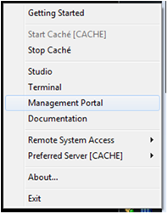

Figure - System Management Portal

1. Select Cache Preferred Server. This is the Cache Server where the Web Application will be installed on.

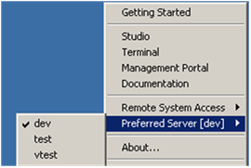

Figure - Select Cache Server

1. Access **Web Application** by traversing **System Administration, Security, Applications, Web Applications**, and click on **GO** button to add Web application.

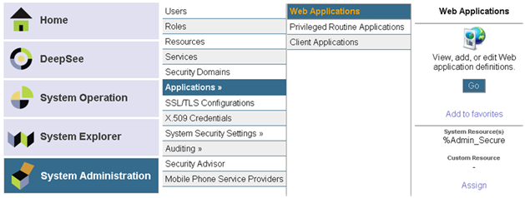

Figure - Web Application

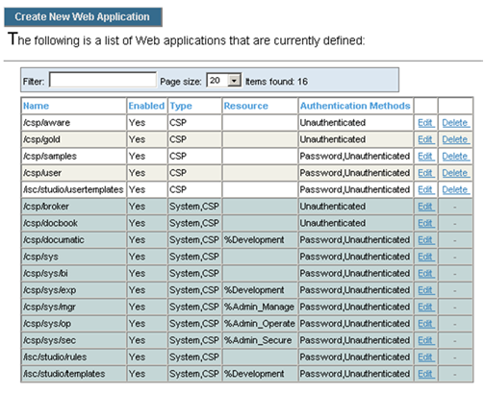

Figure - Create New Web Application

1. Click **Create New Web Application** button.  
   The example below is from the sandbox I2008 VistA Amazon cloud-2 environment.

For test account, change the Web Application Name below to /csptest/aware.

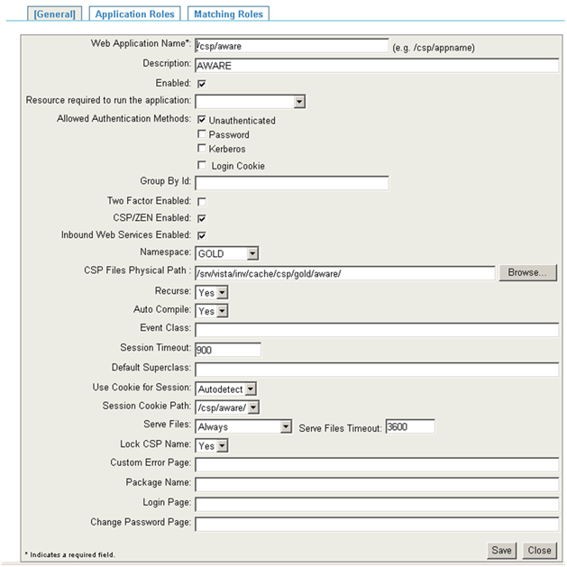

Figure - Web Application Form

1. Change the Namespace and CSP Files Physical Path to reflect appropriate namespace and path.  
   The structure of the path depends on the OS where Cache Server is installed.

For Windows: <drive>:\<cache-install-dir>\CSP\aware\

For UNIX: /<Cache Install-dir>/csp/aware/

For VMS: adjust appropriately. Example: XXX_CACHE$:[XXX.CSP.AWARE] where XXX indicates the 3 characters site identifier

1. Click **Save**.
2. Click on the Application Roles tab and select %DB_%DEFAULT then click Assign button.

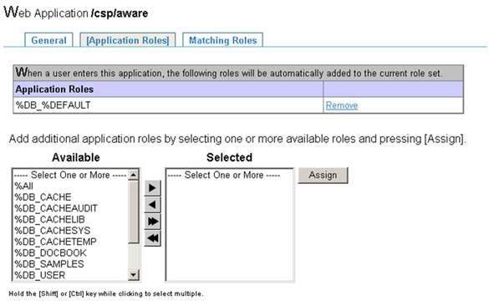

Figure - Web Application Role

1. The CSP application is now configured for AWARE Web Application.
2. Log off the System Management Portal.

### Import Source Code XML

Use Cache Studio to import source code XML.

1. Right click Cache Cube and select Studio.

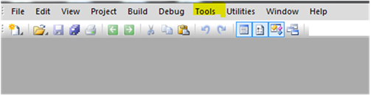

Figure - Cache Studio

1. Select Cache Namespace where CSP source code will be imported.

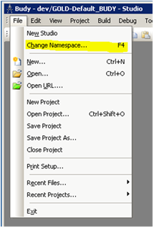

Figure - Choose Change Namespace

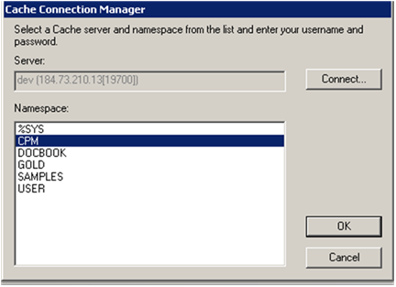

Figure - Select Cache Namespace

1. Click the **Tool** menu and select **Import Local**.

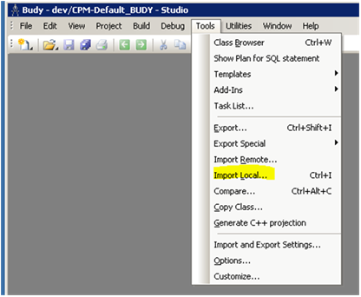

Figure - Import Local

1. Browse and find the previously downloaded VEFA_CSP_V_1_x.XML source code (for production) or VEFA_CSPTEST_V_1_x.xml (for test account). The “x” in the filename represents the last increment.

It is critical to select the correct file for either the test or the production account in order to successfully install CSP pages. The contents of those two xml files are identical but the Web Application locations are different. Since test and production accounts are hosted on the same web server, they are required to have different location.

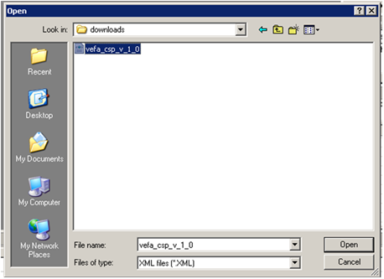

Figure - Select AWARE CSP Source File

1. Click the **Open** button.

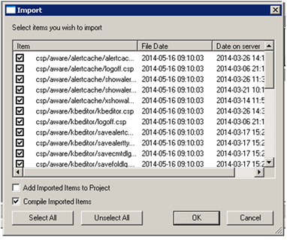

Figure - Import AWARE CSP Source File

1. Verify the **Add Imported Items to Project** checkbox is not selected.
2. Click the **OK** button to import the KB Editor and Alert Viewer CSP source files.

### CSP Gateway User (CSPSystem)

IRM programmer can skip this process if there is already another CSP Web Application running on this VistA instance.

Unless removed, CSP Gateway user should exist in the list of Cache Users. The following depict steps to change password and assign role to user CSPSystem.

1. Access Users by selecting System Administration, Security, and then Users.

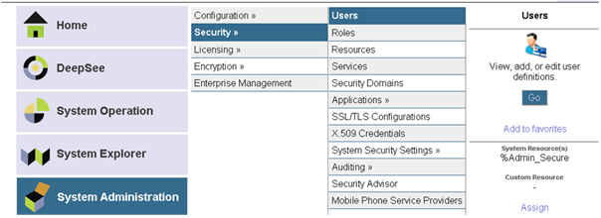

Figure - Launch View, Add, Edit User Definitions

1. Click **GO**.

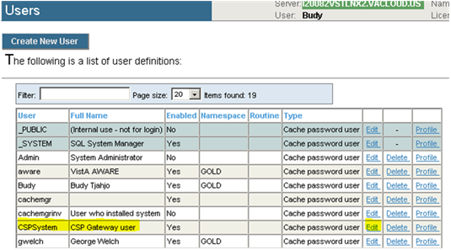

Figure - List of User Definitions

1. Click on Edit link for user CSPSystem.

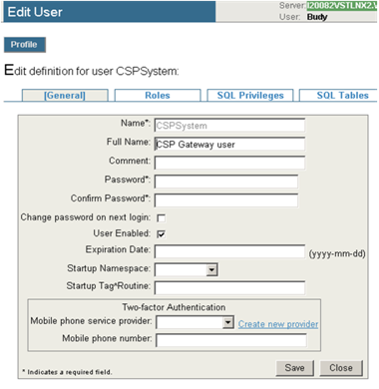

Figure - Edit User CSP System Definition

Modify and confirm CSPSystem password. This password is the same password used during CSP Gateway installation (see T4_AWARE_InstallGde-Server.docx).

1. Assign %DB_DEFAULT role to user CSPSystem.

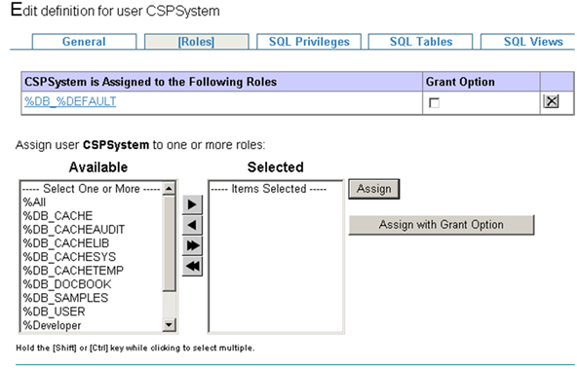

Figure - Assign Role to User CSPSystem

The procedure is complete.

# Terms, Acronyms, Abbreviations, and Definitions

Table – Terms, Acronyms, Abbreviations, and Definitions

|  |  |
| --- | --- |
| Terms, Acronyms, Abbreviations | Definitions |
| AWARE | Alert Watch and Response Engine |
| CSP | Cache Server Page (Intersystems) |
| IIS | Internet Information Services |
| IRM | Information Resource Management |
| KIDS | Kernel Installation and Distribution System |
| MS SQL | Microsoft Structured Query Language |
| SSRS | SQL Server Reporting Services |
| VA | Department of Veterans Affairs |
| VHA | Veterans Health Administration |
| VistA | Veterans Health Information Systems and Technology Architecture |